**PROCESS AVRO FILE AND STORE IN HBASE**

**STEP-1**

**STORED AVRO FILE IN HDFS**

**C:\Users\viks\Desktop\p1.png**

**STEP -2**

**LOAD AND PROCESS IN PIG**

**grunt> A = LOAD '/user/cloudera/twitter.avro' USING AvroStorage()**

**\C:\Users\viks\Desktop\p1.png**

**STEP -3**

**CREATE A TABLE IN HBASE**

**hbase> create 'empl', 'c1'**

**STEP - 4**

**grunt> STORE A INTO 'hbase://empl' USING org.apache.pig.backend.hadoop.hbase.HBaseStorage('c1:username, c1:tweet, c1:timestamp');**

**C:\Users\viks\Desktop\p1.png**

**AFTER RUNNING YOU WILL GET JOB ID**



**YOU WILL DATA IN HBASE**

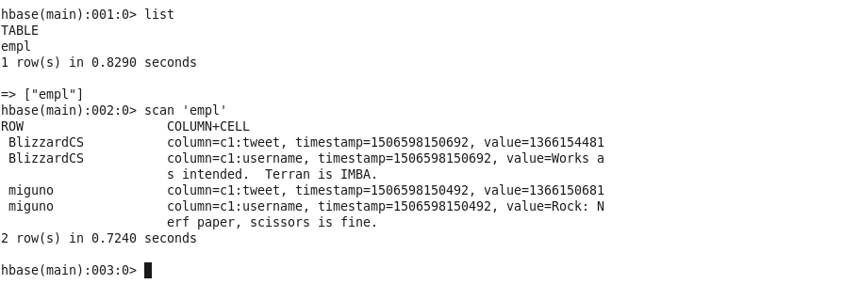

**STEP -5 CHECK HOW MUCH TIME AVRO TAKE TO LOAD IN HBASE BY THEIR JOB_ID**

